Q1. Create a github account if you do not have already.

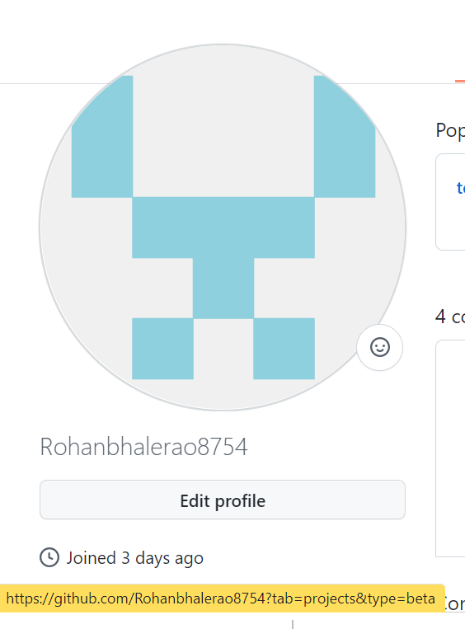

Q2. Login on into github account.



Q3. Create new public repository ‘freshersbatch-oct16’.

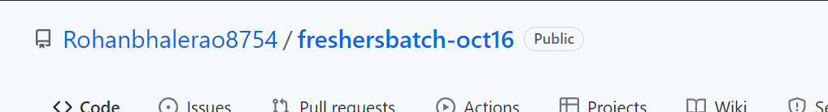

Q4. Commit & push any sample file to this repository under ‘Assignments’ directory.

